Cost generalisation

Meta-analysis average costs by stage

Survival Meta-regression approach - 0 to 5 year annual costs
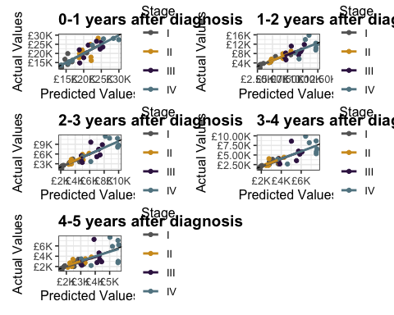

Survival + Immunotherapy Meta-regression approach - 0 to 5 year annual costs

Will et al comparison

